Silverthorne Elementary 

School Growth Plan 2025–2026

We are working towards the following results by June 2026:
- Greater consistency in literacy instruction and improved student achievement in reading.
- A positive, safe school climate where students are increasingly Ready, Independent, Safe, and Kind = R.I.S.K.
- Visible and meaningful integration of Witsuwit’en language and culture throughout the school community.

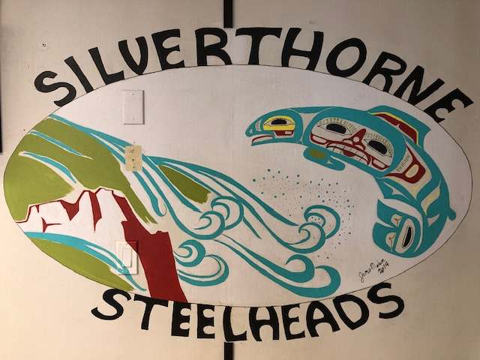

Goal 1- Ensure every student learns foundational literacy skills

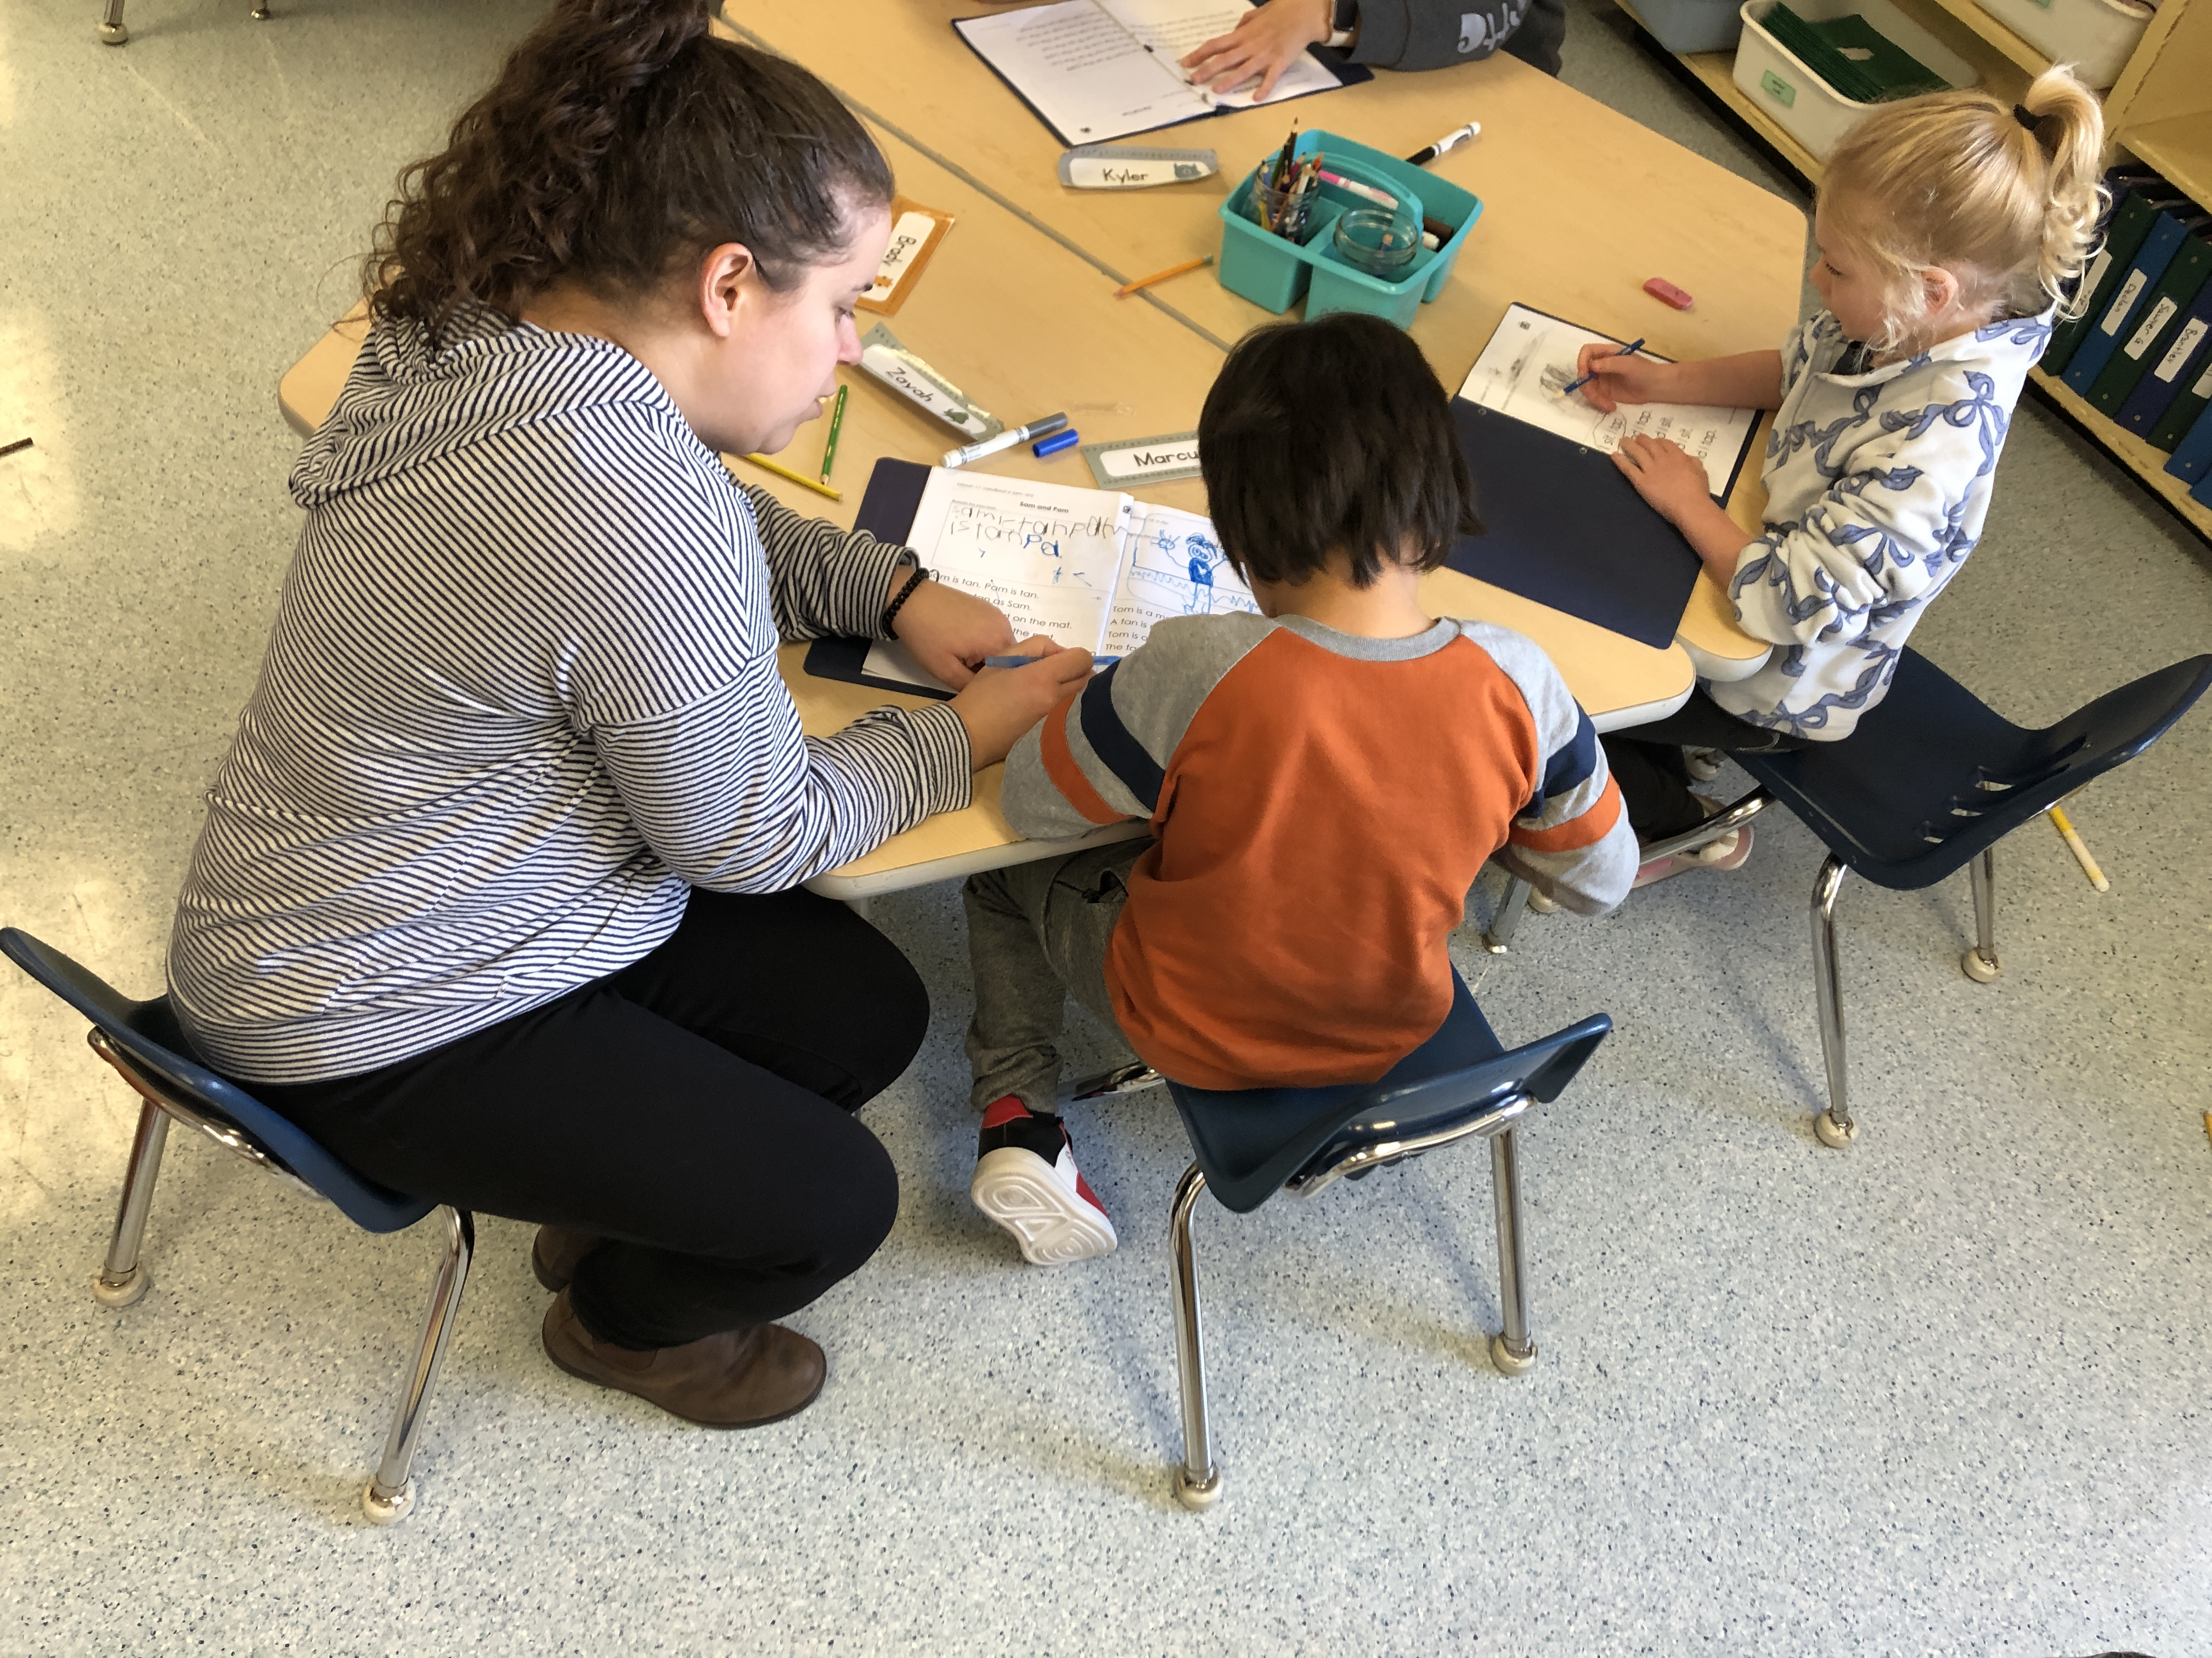
Strategy: Establish a common school-wide approach through the consistent use of UFLI (University of Florida Literacy Institute) across all classrooms.

Rationale
Our school experiences high turnover of staff and students each year, and many of our learners struggle with attendance. This has created significant gaps in phonological awareness and other early literacy foundations, which can be barriers to learning to read. Establishing a shared, consistent literacy approach ensures every student receives the same evidence-based instruction, regardless of classroom placement or staffing changes.

Actions
- Implement UFLI lessons consistently in all K–3 classrooms.
- Provide professional development and ongoing coaching for teachers and support staff.
- Provide staff with resources to support learning and implementation
- Use common assessment tools to track student progress and inform instruction.
- Share strategies and resources with families to reinforce phonological awareness and reading at home.

Measures of Success
- School-wide consistency in literacy instruction.
- Improved targeted outcomes for each student on phonological awareness and reading assessments.
- Families reporting increased confidence supporting literacy at home

Goal 2: Ensure the school is a place where students practice R.I.S.K. (Ready, Independent, Safe, Kind)

Rationale
We want our school to be a safe and supportive environment where there is an understanding that every action or inaction produces an outcome – whether desirable or undesirable. We want to equip our students to establish a pattern of learning to and choosing to conduct themselves in ways that result in favorable outcomes for them and for those around them.
Every action we take, or don’t take, comes with risk:
If we are READY, we trade some thought, preparation, and planning for time.
If we are not ready, we RISK missing out on learning, another activity, or causing others to have to wait for us.

If we are INDEPENDENT, trying things on our own, we trade some frustration, some extra time to learn or get it right, and some fear of doing something new.
If we do not learn to be independent, we RISK not learning new things and having to rely on others to do the things we can do for ourselves and others. This keeps us from growing and being effective contributors.

If we are SAFE, we trade some time and thought considering the results of our actions on the things and people around us (including ourselves).
If we are not safe, we RISK hurting ourselves, others, or damaging property.

If we are KIND, we trade thinking of ourselves first, and considering the needs, feelings, and perspectives of others.
If we are not kind, we RISK hurting others and not having other people trust, respect or like us.
We want Silverthorne to be a safe and supportive environment where students take healthy risks in their learning and relationships. A consistent set of guiding principles helps students, staff, and families know what is expected and encourages responsibility, independence, and kindness in all spaces.

Actions
- Explicitly teach the R.I.S.K. framework across all settings (classroom, playground, hallways, bus, etc.).
- Co-create a school-wide set of guiding principles with staff, students, and families, linked to R.I.S.K.
- Use visuals, assemblies, and classroom activities to reinforce common language.
- Recognize and celebrate students demonstrating R.I.S.K. behaviours.
- Provide families with information and strategies to support the guiding principles at home.

Measures of Success
- Students and staff consistently using R.I.S.K. language.
- Clear guiding principles developed, shared, and visible throughout the school.
- Decrease in unsafe or unkind behaviours, as measured by office referrals or incident reports.
- Positive feedback in family and student surveys about school climate.

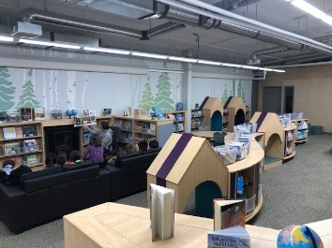

Goal 3: Increase the use of Witsuwit’en language as part of the school’s common language

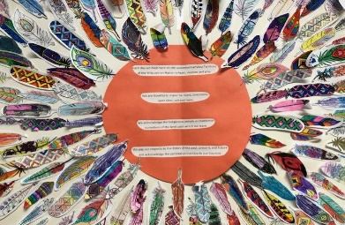

Rationale
Our school is located on Witsuwit’en territory. Embedding the Witsuwit’en language into our daily school life acknowledges and supports our Indigenous students while valuing cultural identity for all. This practice strengthens reconciliation efforts, builds respect, and reflects our community context.

Actions
- Incorporate common meaningful Witsuwit’en words and phrases into school routines (greetings, acknowledgements, announcements).
- Partner with Witsuwit’en knowledge keepers and language teachers to guide authentic use of language.
- Display Witsuwit’en language on school signage, classroom labels, and learning materials.
- Encourage staff to model and use Witsuwit’en language daily in interactions with students.
- Celebrate cultural events and learning opportunities connected to Witsuwit’en traditions and knowledge.

Measures of Success
- Witsuwit’en language visibly and audibly present in daily school routines.
- Students and staff able to use basic Witsuwit’en words and phrases with confidence.
- Increased connections with Indigenous families and community members.

